Type of data structures

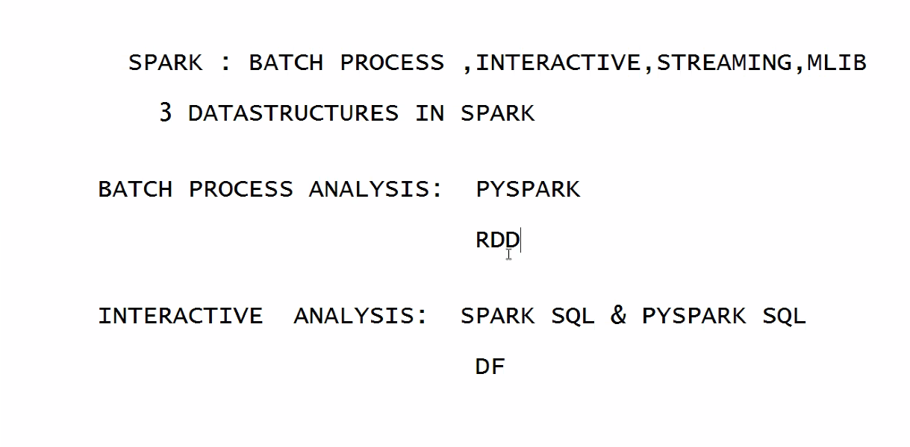

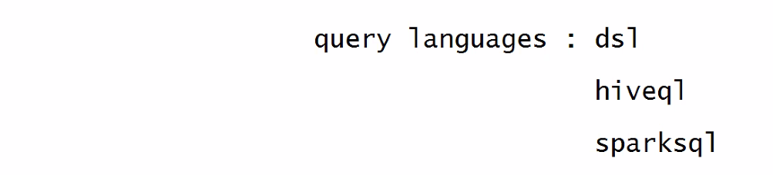

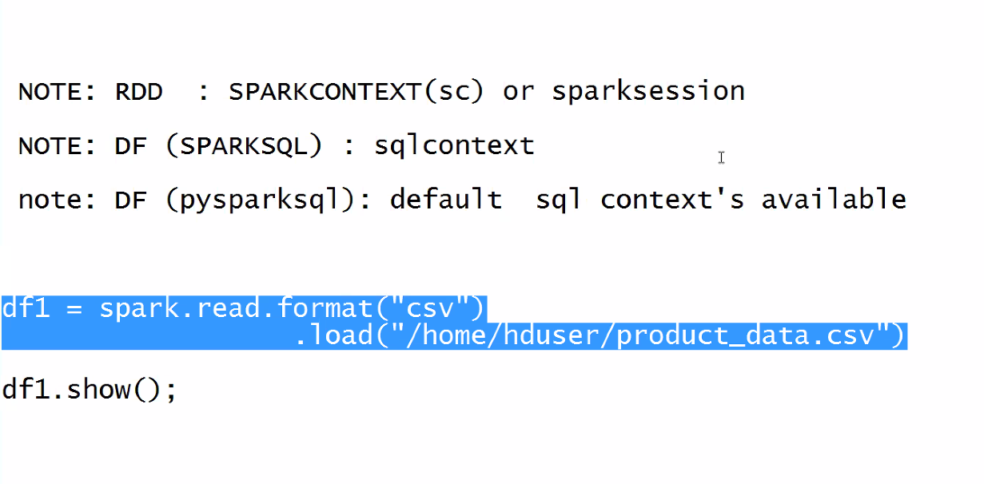

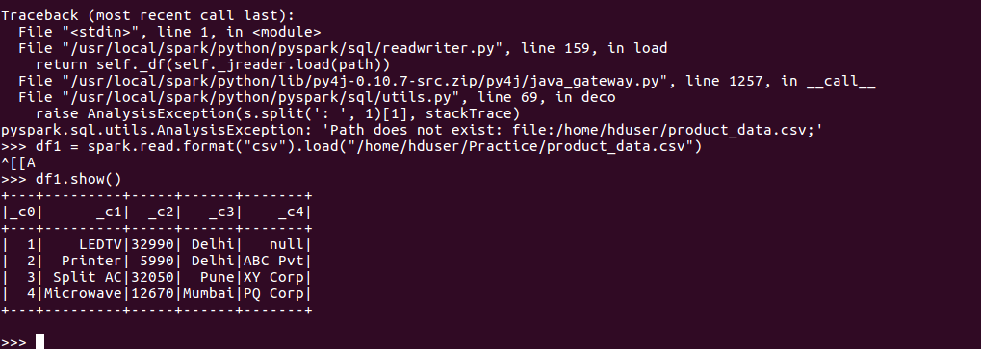

Load file with headers

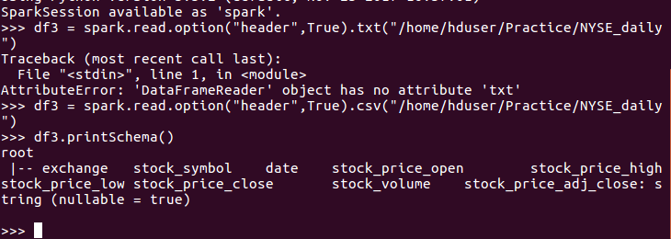

df3 = spark.read.option("header",True).csv("/home/hduser/Practice/NYSE_daily")

df3 = spark.read.options(inferSchema='True',delimeter=',').csv("/home/hduser/Practice/NYSE_daily")

df3 = spark.read.options(inferSchema='True',delimeter=',',header='True').csv("/home/hduser/Practice/NYSE_daily")

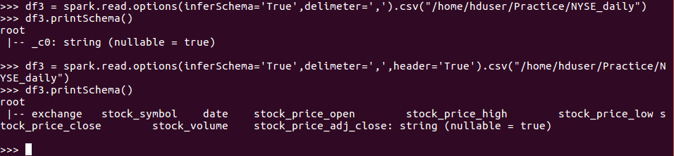

Upcoming

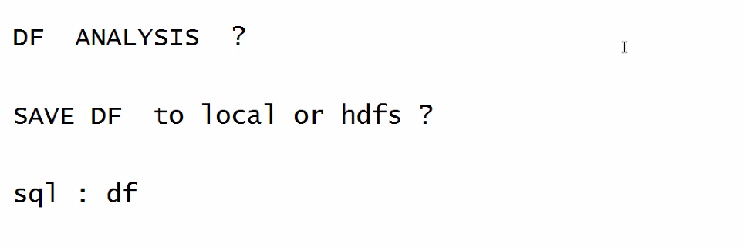

Dsl instead sql

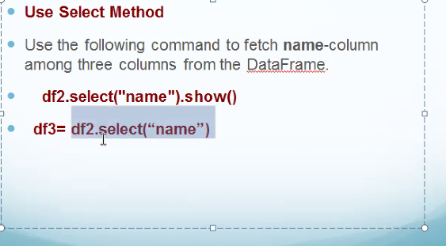

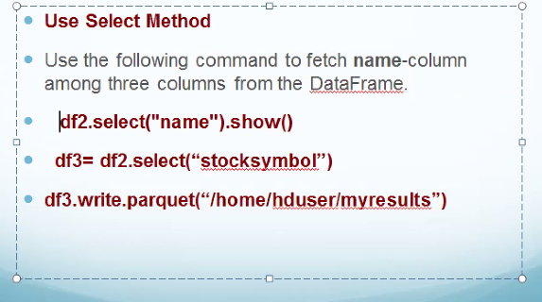

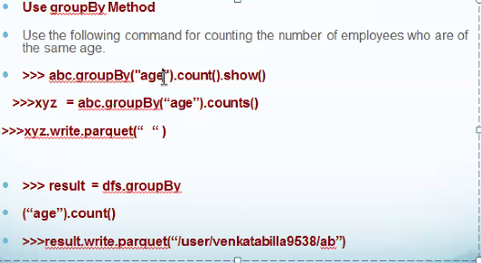

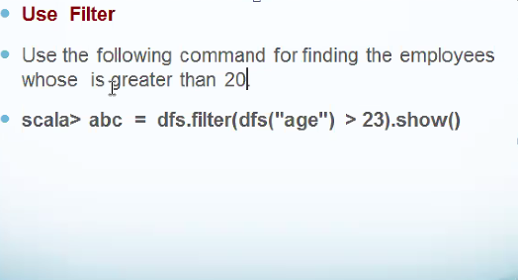

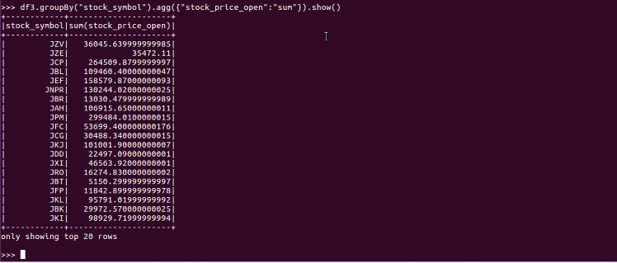

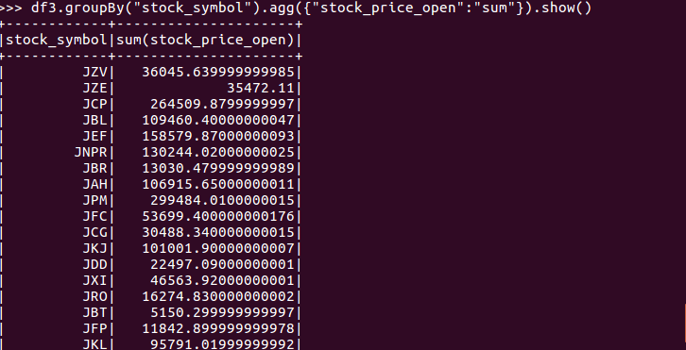

Sql instead of dsl

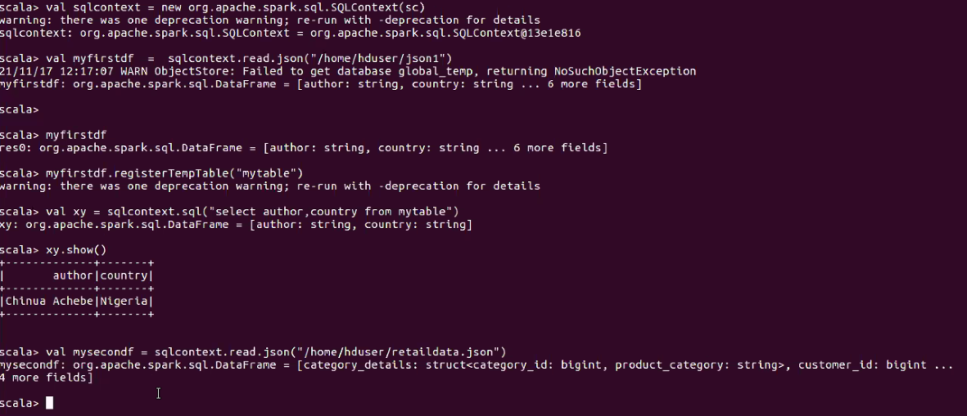

Before sql ops store as temp table

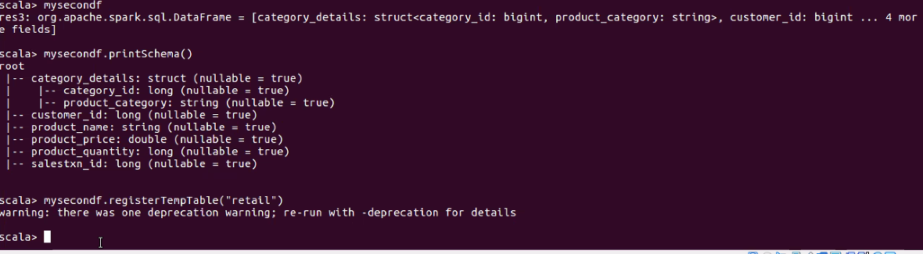

Total product price by customer

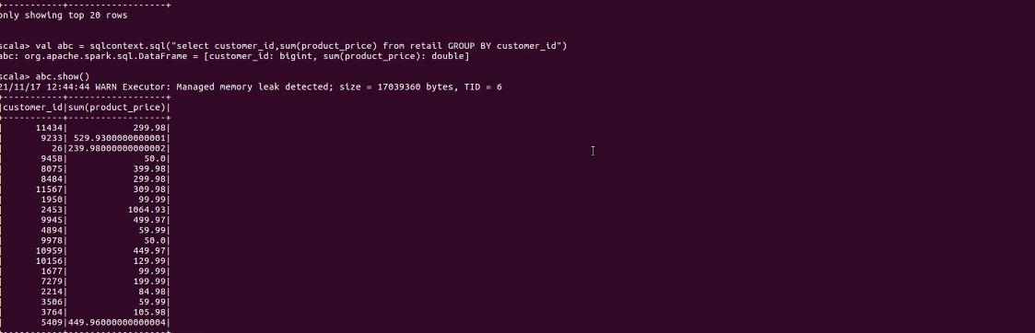

Max price

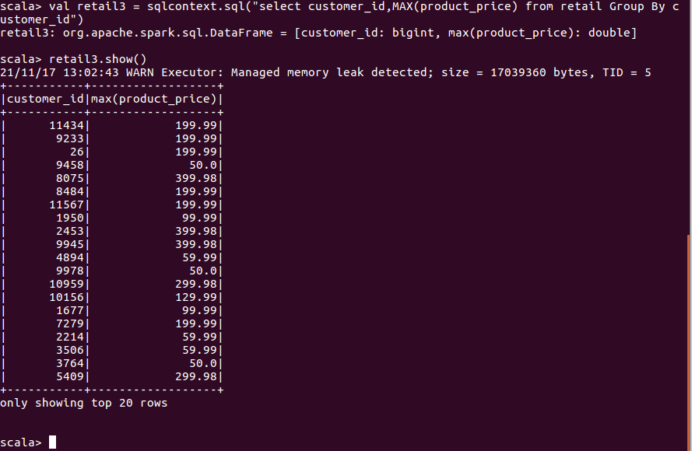

Show temp table

val retail3 = sqlcontext.sql("select * from retail")

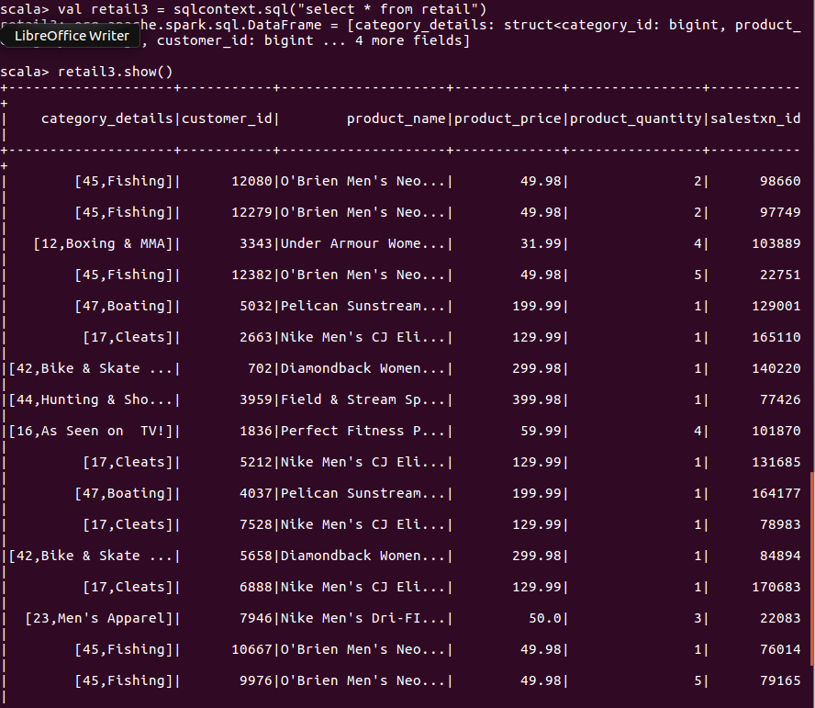

Pyspark join exercise

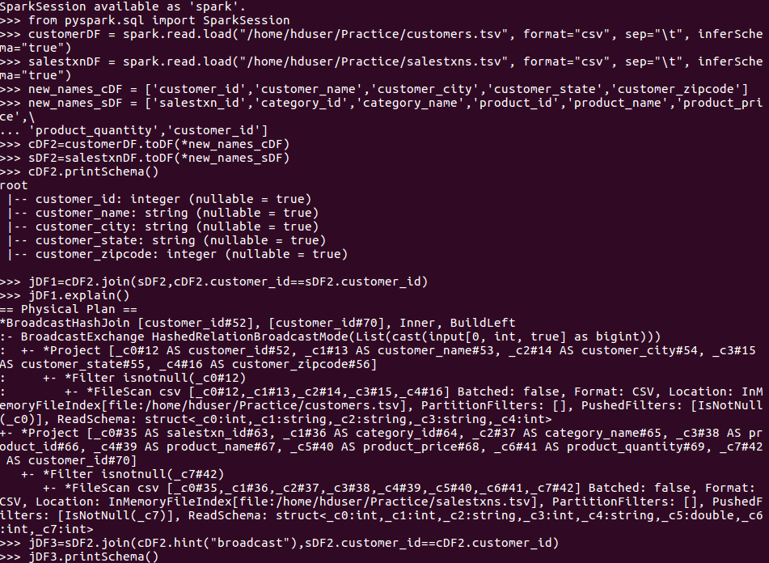

Load text file and create a dataframe from that example

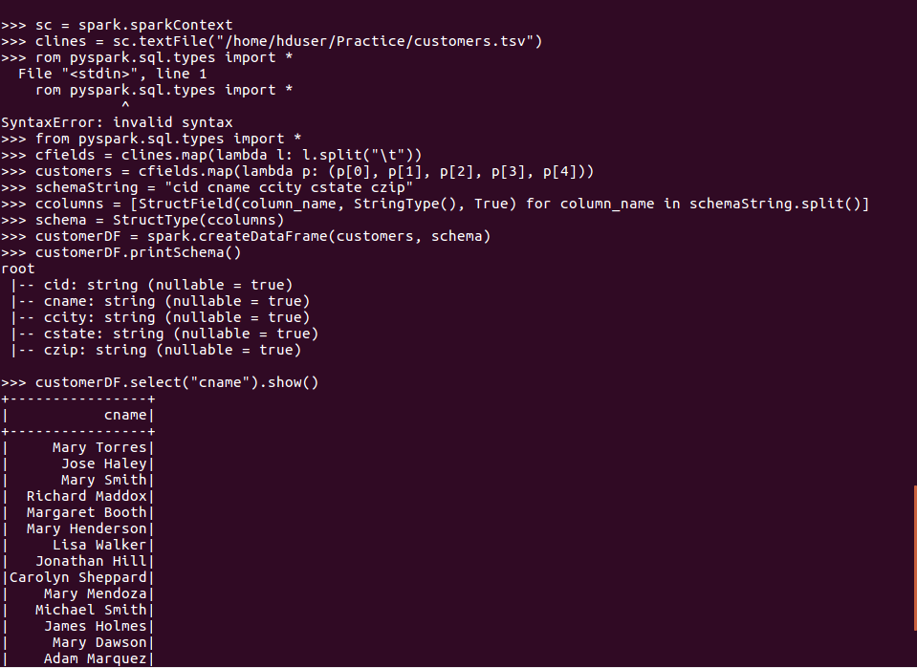

Further, follow ipynb examples downloaded from jigsaw

